**i2si_bist_gen.v Testing – Zachary Nelson**

**Interfaces:**

|  |  |  |  |
| --- | --- | --- | --- |
| Signal Name | Direction | Bits | Comment |
| clk | in | 1 | Master Clock |
| rst | in | 1 | Reset |
| rf_bist_start_val | in | 12 | Start Value |
| rf_bist_inc | in | 8 | Increment |
| rf_bist_up_limit | in | 12 | Upper Limit |
| i2si_bist_out_data | out | 12 | Output Data |

**Testing Description:**

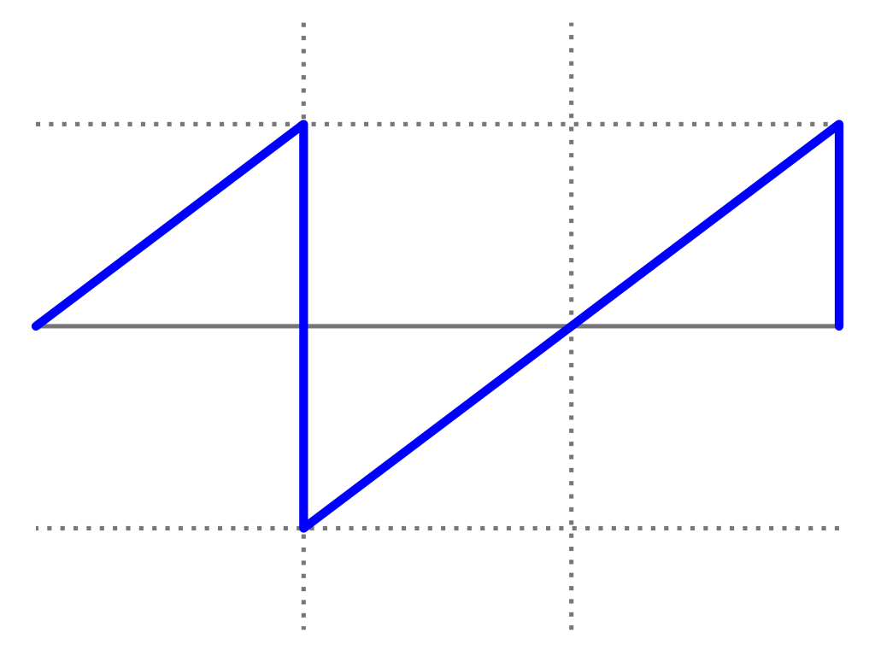

**Fig 1. Example of a saw-tooth signal**

* The goal of this module was to generate a saw-tooth wave signal and output it from the module.
* The wave was set to start at rf_bist_start_val and was incremented by rf_bist_inc until the value of rf_bist_up_limit was reached. When the upper limit was reached, the value would drop back to the start value.

**bist_gen_test.v Description:**

rf_bist_start_val = 0x001

rf_bist_inc = 0x001

rf_bist_up_limit = 0x19

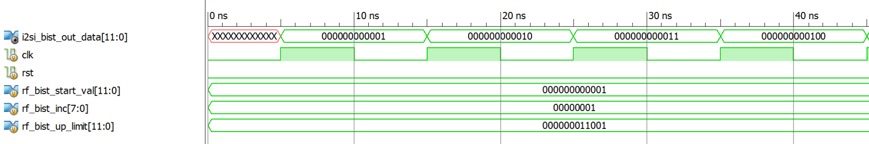

**Fig 2. The start of the BIST generator**

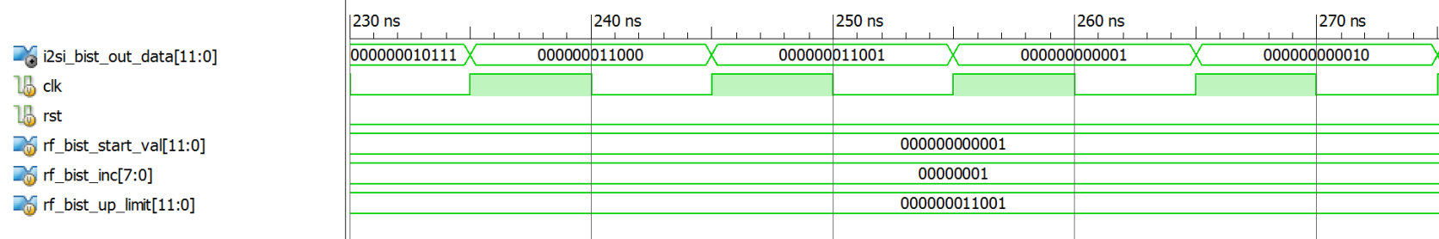

**Fig 3. BIST generator hitting the max value**